Online Bank Management

Done By:

* MD NAFIJUL HOQ - 20-42366-1

Showing all the values in the tables below:

1. Bank

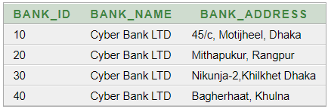

1. Employee

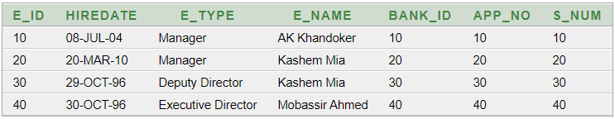

1. App

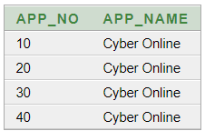

1. CustomerInfo

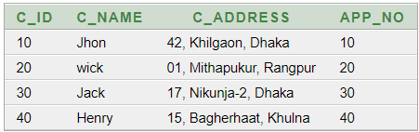

1. Customer_phone_number

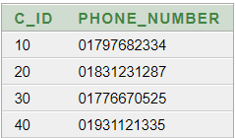

1. Loan

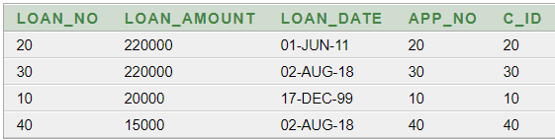

1. Account

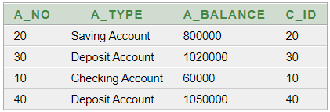

1. Transaction_records

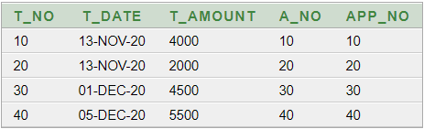

1. Salary

